Press Release

ECO appreciates the initiatives being pursued by ECO Science Foundation for promotion of Science and Technology in the Region

The President of the ECO Science Foundation (ECOSF), Prof. Dr. Manzoor Hussain Soomro visited the ECO Secretariat, Tehran and held a meeting with Mr. Hayri Maraslioglu, Deputy Secretary General (AIT/T&I/IR) on September 04, 2014 to discuss progress of ECOSF.
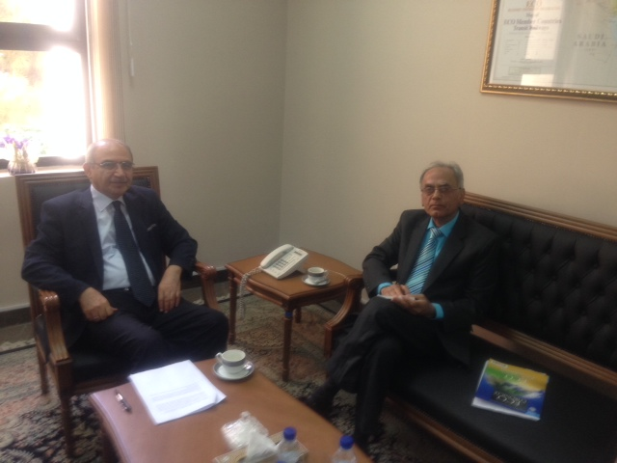

The Deputy Secretary General welcomed the ECOSF President and appreciated the initiatives being pursued by the Foundation for promotion of science and technology in the ECO region. In particular, he congratulated the ECO Science Foundation President on being elected as Member of the Governing Board of International Science, Technology and Innovation Centre for South-South Cooperation under the auspices of UNESCO (ISTIC), Kuala Lumpur, Malaysia. The Deputy Secretary General also felicitated ECOSF on being accredited as Observer/Stakeholder of Intergovernmental Science and Policy Platform on Biodiversity and Ecosystem Services (IPBES) based in Bonn - Germany. He expressed the hope that engagement with these regional and international peers in the field of science and technology would support the broad objectives of ECO.
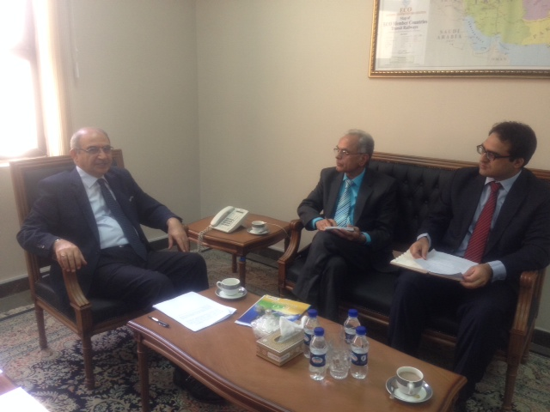

The ECOSF President briefed the Secretariat that the Foundation is co-organizing an International Conference on “Emerging Trends in Life Sciences for Sustainable Development” on 9-11 October 2014 in Lahore, Pakistan. The main objective of the Conference is to enable the scientists from ECO countries to share their relevant experiences and to promote collaboration among the scientific community in the region. He also expressed confidence that the event would result in furthering the cooperation among the scientific community in the region.
The ECOSF President also held discussions with the Director (Energy/Minerals/Environment) at the ECO Secretariat and stressed on the need for a coordinated approach in pursuing important initiatives in the field of environment and biodiversity.
-------------------

